**Password Auditing**

**A bit of review**

**??**

**?**

**So, remind me**

**Well… they are the keys** ◂

◂ 

◂

**How to make a password *effectively***

◂

◂

◂

◂

◂ 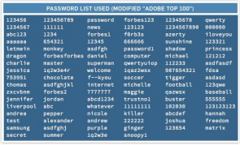

◂

**Mix it up!**

**Changing user passwords**



**passwd -l root**



**Batch password changes**

**Now, do you think everyone Will actually make good**

**passwords?**



**/etc/sudoers**

**/etc/sudoers**

**/etc/sudoers**

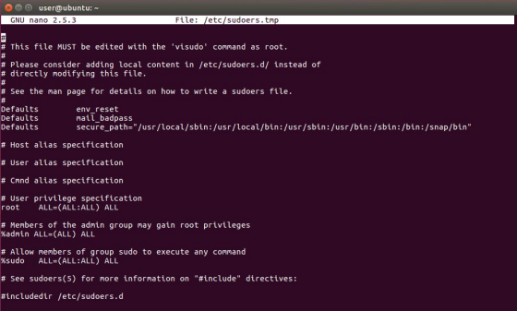

**/etc/login.defs**

**chage**

**PAM**

**sudo apt install libpam-cracklib**

**common-auth**

**common-password**

**common-password**

**common-password**

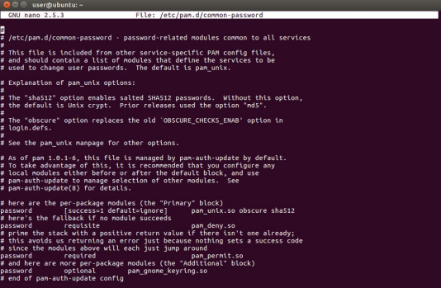

**common-auth**

**common-auth**

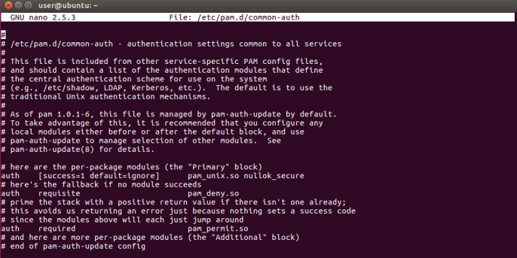

**/etc/sudoers**